**React Coding Challenge: Advanced Routing & State Management  
  
Image 1:**

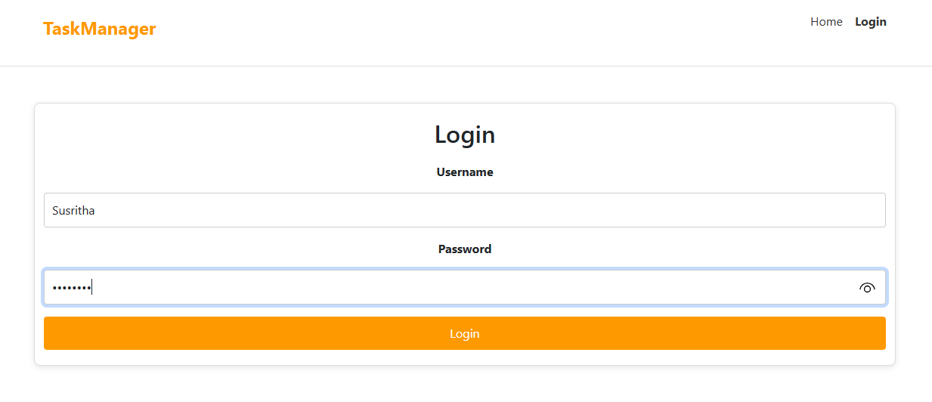

**Image 2:**

